**DEPARTMENT OF ELECTRONIC AND TELECOMMUNICATION ENGINEERING**

**UNIVERSITY OF MORATUWA**



**EN3160 - Image Processing and Machine Vision**

Assignment 02

Fitting and Alignment

**PUSHPAKUMARA H.M.R.M.**

**200488E**

September 01, 2023

**Question 01**

Here we have to detect blobs by using Gaussian and scale-space extrema detection.

I used sigma = 1 and sigma = 2 as my sigma values and my threshold value is 0.35.

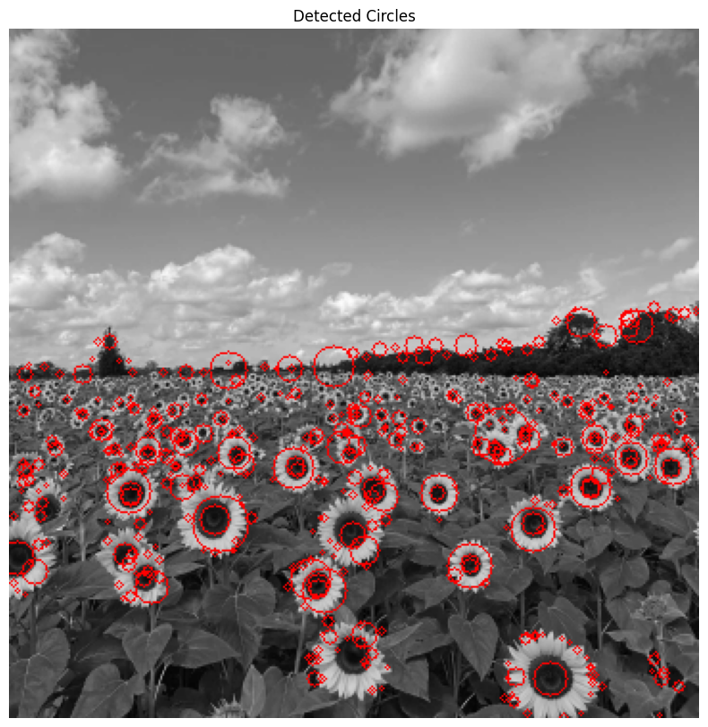

Parameters of the largest circle:

* Center: (110, 258)
* Radius: 20
* Sigma value: 2

**Question 02**

**(a)**

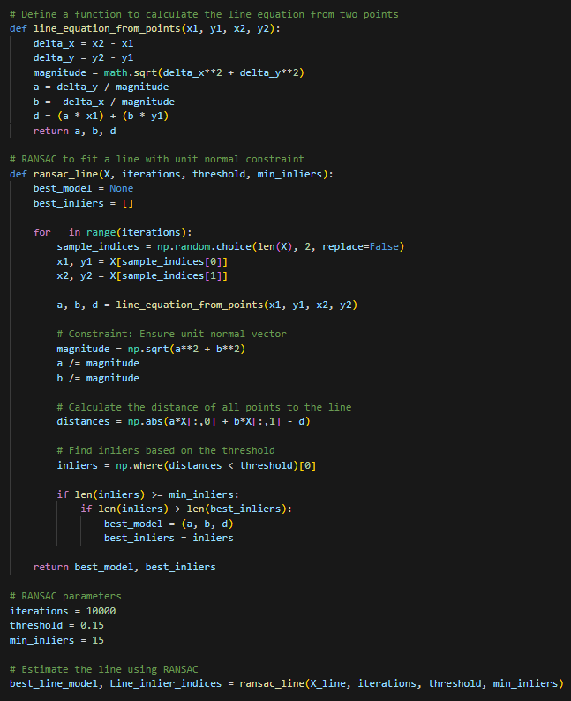

**(b)**

**(c)**

**Question 03**

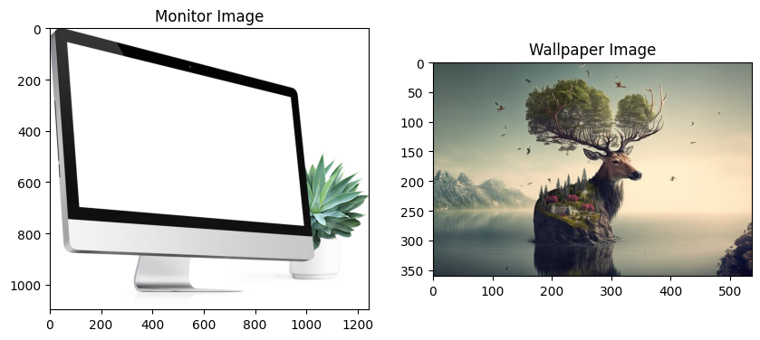

<https://github.com/RavinduMPK/EN3160---Image-Processing-and-Machine-Vision>

Direct to the assignment:

<https://github.com/RavinduMPK/EN3160---Image-Processing-and-Machine-Vision/tree/main/Assignment_01%20-%20Intensity%20Transformations%20and%20Neighborhood%20Filtering>